##### 

**Building Leadership Capacity**

[](https://pixabay.com/en/wind-farm-wind-energy-1747331/)

**Embracing Change**

##### Embracing Change

Copyright 2010-2018 New Reality Leadership, LLC

*New Reality Leadership*

**Maximizing change in your work and life**

**Overview**

Change in our lives is so exponential that by the time we get through the change, it is almost obsolete. Change is happening all around us and to us. In our work, we can let change rule us or we can take advantage of it to creatively and innovatively thrive through it. We will discuss areas that will help employees see the rapidly changing world, why we need to adapt, and how you can personally navigate through the white-water times and come out stronger. Developing this competency is a key competitive advantage for the company by allowing the company to think faster and more creatively than competitors who settle for the status quo.

|  |  |  |
| --- | --- | --- |
| [Wind Farm, Wind Energy, Renewable Energy](https://pixabay.com/en/wind-farm-wind-energy-1747331/) |  | **Objectives**   1. Discover why keeping up with change is critical to staying competitive 2. Maximize the personal value of change 3. Apply practical steps to navigate through change |
|  |  | **Contents**     * 1. The Case for Embracing Change   2. The Change Curve   3. The Competency Connection   4. Assessing your Approach to Change   5. Personal Application   6. Summary   What i |
|  |  |  |

**1. The Case for Embracing Change**

The Swiss had 80% of the watch market, invented the next generation digital watch, failed to implement it and lost 60% of the market. Change is tough for companies and people. In the 1800s, change was slow. The pace today is exponential. We can make the most of it we if choose to be proactive. In some cases, change is part of life where we lose a job or a loved one. We can navigate through changes more effectively if we understand and apply a few principles.

**The Business Case for Change**

Maximizing change also has a business impact. By taking charge of change you will grow and develop to take on expanded future responsibilities thereby maximizing your potential. The ultimate role of a leader is to optimize the performance of the team. The role of the employee is to take advantage of various opportunities to grow and develop. Change provides unique opportunities.

***Business success in the future will depend on the ability of managers to lead their business through changes and for employees to take on the new challenges with flexibility, patience, initiative, anticipation and even excitement.***



Change situations provide unique opportunities for personal growth that you may not get any other way. By taking charge and mining these opportunities, you can grow and develop towards your full potential

**Exponential Change**

List 5-10 changes that have occurred in the last several years.

There are a series of videos called Did You Know? Or Shift Happens. Take a look at one of these to understand the rapid rate of change we are going through in this generation.

List insights from the video.

# Shenzhen: Before and After

The pictures below show the huge changes in Shenzhen, China from just before 1980 to 2018. This is one of the fastest development changes in history. Shenzhen went from a fishing town to exporting billions of dollars of merchandise a year in less than 30 years.

1980

30,000 people



2018

17 Million People



Credit: [Ming Chen Photography](mailto:%3ca%20style=%22background-color:black;color:white;text-decoration:none;padding:4px%206px;font-family:-apple-system,%20BlinkMacSystemFont,%20&quot;San%20Francisco&quot;,%20&quot;Helvetica%20Neue&quot;,%20Helvetica,%20Ubuntu,%20Roboto,%20Noto,%20&quot;Segoe%20UI&quot;,%20Arial,%20sans-serif;font-size:12px;font-weight:bold;line-height:1.2;display:inline-block;border-radius:3px;%22%20href=%22https://unsplash.com/@pisceschen?utm_medium=referral&amp;utm_campaign=photographer-credit&amp;utm_content=creditBadge%22%20target=%22_blank%22%20rel=%22noopener%20noreferrer%22%20title=%22Download%20free%20do%20whatever%20you%20want%20high-resolution%20photos%20from%20ming%20chen%22%3e%3cspan%20style=%22display:inline-block;padding:2px%203px;%22%3e%3csvg%20xmlns=%22http://www.w3.org/2000/svg%22%20style=%22height:12px;width:auto;position:relative;vertical-align:middle;top:-1px;fill:white;%22%20viewBox=%220%200%2032%2032%22%3e%3ctitle%3eunsplash-logo%3c/title%3e%3cpath%20d=%22M20.8%2018.1c0%202.7-2.2%204.8-4.8%204.8s-4.8-2.1-4.8-4.8c0-2.7%202.2-4.8%204.8-4.8%202.7.1%204.8%202.2%204.8%204.8zm11.2-7.4v14.9c0%202.3-1.9%204.3-4.3%204.3h-23.4c-2.4%200-4.3-1.9-4.3-4.3v-15c0-2.3%201.9-4.3%204.3-4.3h3.7l.8-2.3c.4-1.1%201.7-2%202.9-2h8.6c1.2%200%202.5.9%202.9%202l.8%202.4h3.7c2.4%200%204.3%201.9%204.3%204.3zm-8.6%207.5c0-4.1-3.3-7.5-7.5-7.5-4.1%200-7.5%203.4-7.5%207.5s3.3%207.5%207.5%207.5c4.2-.1%207.5-3.4%207.5-7.5z%22%3e%3c/path%3e%3c/svg%3e%3c/span%3e%3cspan%20style=%22display:inline-block;padding:2px%203px;%22%3eming%20chen%3c/span%3e%3c/a%3e)

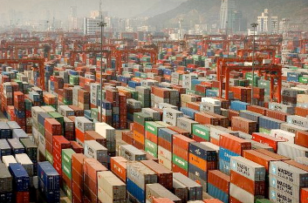Shenzhen did not have any exports in 1980. Today, it is the third largest shipping port in the world. Guangzhou is part of the same economic expansion as Shenzhen. Its exports have risen four times since 2004.

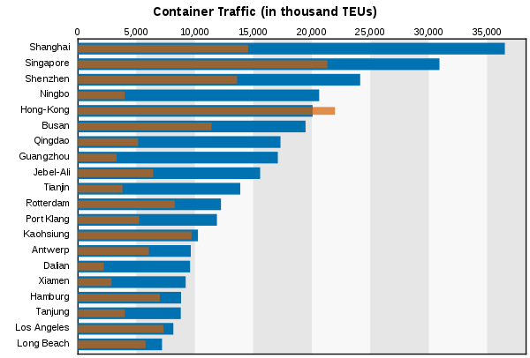

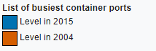 Source: [World Shipping Council](http://www.worldshipping.org/about-the-industry/global-trade/top-50-world-container-ports)

Shenzhen and Guangzhou together ship over 100 containers per minute. Their exports in 1980 were zero.

Think about what you have seen on the Did you Know Video and on the slides of Shenzhen. Discuss these questions:

* What strikes you most about these situations?
* What implications do you see based these changes? That is, what does your business need to consider going forward to be successful?
* What other thoughts do you have?

**Exercise Case**



Dealing with negative personal change

**Wall Street**

In 1929, the value of the stock market dropped so drastically that many wealthy people lost almost everything. People who thought they were wealthy forever instantly were worth nothing. Some people never made it through the trial and gave up. Some took their lives. Some held on to the anger, bitterness, and fear for years. However, others worked the process and while painful, recovered and managed. Some made out very well while others recovered to a steady state. The key was how each person viewed the change and what choices they made to go forward.

Think about a change that impacted you personally.

* What was the initial negative impact on you?

* What did you learn through the experience?
* If it has been a while since the change, can you identify one or two positive outcomes or learnings that you see from this change?

**2. The Change Curve**

There are approaches we can personally take to manage change. We need to understand how most people go through stages of change. By knowing the process, we can take charge of the change. Secondly, we can apply these principles to specific changes we are facing. While this model and process work for most changes, dealing with severe circumstances such as loss of life, natural disasters, personal illnesses, etc. may require much more support and time to process.

**The Change Process**

It is essential to understand how most people step through life changes. The curve shown here is the model we will use.

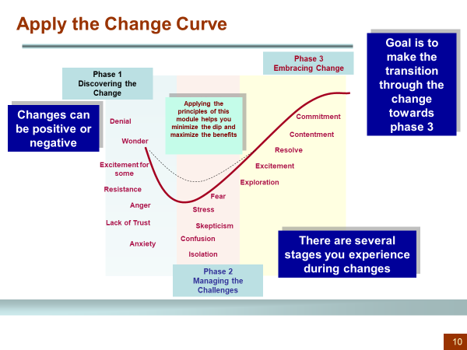

Focus areas:



* Change can be positive or negative. Even with a positive change, there is often a dip as represented. Think of buying a house, having a child, or getting a new job. Each has unique circumstances to work through. In these cases, unless forced on you, you may not experience resistance, lack of trust or anger. You may experience wonder, excitement, and some anxiety. In adverse changes or ones you did not have control over, you may experience some of the other feelings.
* There are several stages in change. In the first stage, we are learning about the change and sorting through emotionally how it will impact us. Depending on the type of change, this time can be very challenging, confusing and filled with ambiguity. The dip represents the second phase where you are deep into the change or transition. This phase can be stressful and confusing. You may feel isolated or have some fears. You may not feel as competent and may wonder if you can transition to a new place effectively.
* With support and perseverance, the goal is to move into the third phase where we start to see new possibilities that bring on a sense of excitement and eventually commitment. With tough changes such as a loss of a job or death of family or friends, you will not feel excited but there are ways to reach a new steady state or resolve and contentment which may take significant time.
* As an individual, you can step through these changes by following some practical steps as listed here. You can not rush the transition, but you can proactively take charge of the change rather than letting the change take charge of you.

**Steps to Take to Embrace Change**

As you look at the suggested ideas, check the which ones you would like to improve. There is also an assessment that will help you identify your focus areas.

Before facing a change

* Prepare for potential changes the best you can. The world is changing quickly and what is stable today may be much different in the future.
* Take to heart the examples of change above.
* Help others manage the change.
* Be proactive and look at future possibilities of how to grow your skills.
* Think about *What if* type questions in a positive way. For example, what if I lost my job….what if I got transferred, or disabled in some way. Prepare where you can for future calamities.
* Diversify where it makes sense. We talk about financial diversification. Think about skill or business diversification as other examples.

What else might you personally do?

*The only constant we may have in life is change*

**Challenging Changes**

**During Phase 1 of challenging changes:**

* Don’t panic.
* Spend more time asking questions. Don’t make assumptions or read into situations before knowing the facts.

Ambiguity

To

Commitment

* Don’t shoot the messenger. Often the person telling you about a change is not the one responsible for initiating the change.
* Find time to get away from the situation to relax or find calming surroundings; do something you like to do.
* Be inquisitive without being resistant. Ask questions with a purpose and not to antagonize.
* Don’t make any rash decisions. If a difficult decision can be made later, let it go for now.

**During Phase 2**

* Keep going even in the ambiguity.
* Continue to be inquisitive. Find answers to the unknown.
* Do not be afraid to ask leaders or others tough questions. You can still be positive but focused.
* Don’t guess or read into things. Don’t assume things that might be.
* Don’t give up; take charge and make something happen when possible.
* Seek out feedback from others and listen for advice and ideas.
* Find ways to encourage peers and even your leaders. Your immediate leader may not have much more control or information than you.

**During Phase 3**

* Continue to take charge.
* Discover new possibilities.
* Help others explore.
* Listen to others who may still be in phase 2. Allow time to discuss the problematic areas and then ask them for next steps they might consider (be careful not to be too ambitious too soon).
* Be willing to learn new things.
* Learn to accept what is impossible to change.

**Benefits of Change**

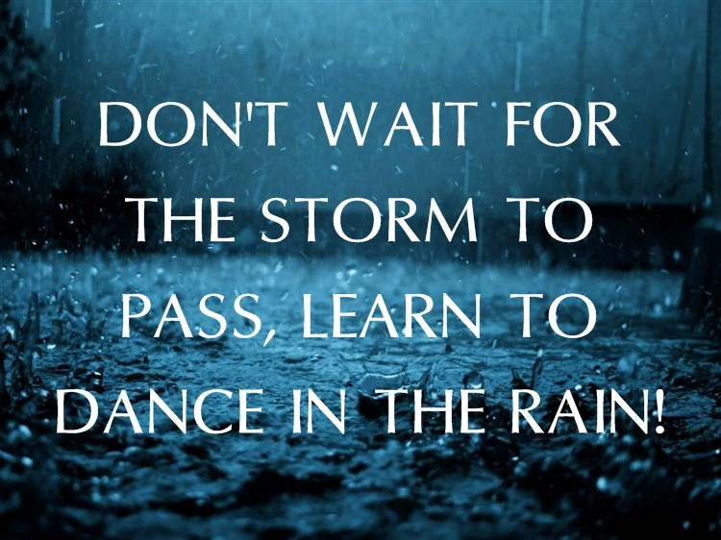

Of the changes you listed earlier, list benefits you gained due to the change. For example, if you lost your job, possibly you found a better job or learned new skills in the next position.

**Positive Changes**

**During Phase 1 of Positive Changes**

* Ask questions and find out as much information as possible.
* Communicate to others as needed about the changes especially if it may also impact them.
* Think about loose ends to close out if this applies — for example, a move or a new job.

**During Phase 2**

* Realize there will be times of ambiguity.
* Be patient as you learn new skills and knowledge.
* Seek out mentors or others who can help and support you.
* Continue to communicate with others appropriately.
* Take time to relax and slow down if the pace is fast.

**During Phase 3**

* View this time as an accelerated learning opportunity.
* Explore opportunities that may be new.
* Try new things and push yourself some outside of your comfort zone.
* Determine who to communicate with and when.
* Find ways to increase your network and collaboration with others.

Think about a *positive change* you encountered such as getting married, having a child, getting a promotion, or buying a house. Describe how you felt:

As you began the change?

What unknowns or other areas created some fear, anxiety or nervousness?

How do you feel today about this change?



**3. The Competency Connection**

A success factor in today’s workers is their ability to handle change and even maximize change in their lives. This is a competency that can be learned. As you apply for or interview for new positions, interviewers will assess you on difficult changes you encountered and how you managed them. The interviewer will ask questions that will help them to see if you took charge of the changes, tried to learn new things, helped others, stayed flexible….or were resistant or overly anxious during the change. The world is too fluid now to hire employees who will resist constant changes.

One way to help manage through a change is to ask this question:

***If I were to interview for a job in several years and they asked me how I handled a difficult change, how could I learn to take charge of a change now and build a great answer for that interview question?***

If you think about that response and then apply those behaviors to current changes, your behavior may be different. For example, if you feel resistant right now, can you be more proactive in working with leaders to understand the change and share possible solutions? Can you let the minor points go and focus on the major aspects? This behavior shows your flexibility. Can you help someone else in this change right now? This focus shows your concern for others and the company vs. a more self-centered approach.

Approaching a current change positively prepares you to provide a robust and credible answer to this type of interview question and build confidence for the interviewer of your value.

A person was involved in a change where he knew he could lose his position or be assigned to a different business in the company. Rather than fret and wonder, he did three specific things:

* He spent extra time supporting his coworkers by listening and encouraging them during the waiting time
* He ensured what he did know was documented and available to others if he was not in the position
* Periodically he would ask his leaders how they were doing. He knew they also would be going through position changes but had little support or encouragement.

**Exercise**

If you are in a classroom session, pair up with a partner and interview each other with the question above. Then discuss your approach with one opportunity for improvement in your current approach to a change you are facing. If you are doing this as a self-study, list your answer here to this question. If you have completed the Tier Model Assessment, there are good Tier 3 characteristics to consider during change.

*One of the best WAYS TO BUILD COMPETENCY DURING CHANGE IS TO support others on your team during the change*

 4. **Assessing your** **Approach to Change**

This assessment indicates how you currently approach change. Think of changes you have gone through during the last few years and mark which statement more accurately describes your reaction to the changes. Answer the assessment honestly by circling the answer that best describes you. You will be the only person to see the answers. If you find neither answer fits, write down additional comments in the space provided at the end of the assessment.

|  |  |  |
| --- | --- | --- |
|  | **Description** | **Response** |
| 1 | I struggle during most changes | A |
|  | I am resilient during changes | B |

|  |  |  |
| --- | --- | --- |
| 2 | I am often anxious and worry during changes | A |
|  | I take one day at a time during changes and work through the process | B |

|  |  |  |
| --- | --- | --- |
| 3 | I tend to see more of the negative side of change | A |
|  | I tend to look for the positives during change | B |

|  |  |  |
| --- | --- | --- |
| 4 | I am not as productive during uncomfortable change | A |
|  | I continue to find ways to get things done during change | B |

|  |  |  |
| --- | --- | --- |
| 5 | I like to keep things the way they are for the most part | A |
|  | I am flexible during change and can often go with the flow | B |

|  |  |  |
| --- | --- | --- |
| 6 | I tend just to follow what leaders ask of me during the change | A |
|  | I take the initiative during changes to find out what the change is about and how I can help support it | B |

|  |  |  |
| --- | --- | --- |
| 7 | I have not learned much from past changes | A |
|  | I have learned new things from past changes | B |

|  |  |  |
| --- | --- | --- |
| 8 | I tend to focus more on myself during uncomfortable changes | A |
|  | I try to listen to others and help them during the changes | B |

|  |  |  |
| --- | --- | --- |
| 9 | I am still upset by some past decisions made during changes | A |
|  | I tend to recover from changes even when things did not go so well | B |

|  |  |  |
| --- | --- | --- |
| 10 | I am pretty set in my ways and do not often try new things | A |
|  | I like to try new things and attempt to learn new ways of doing things | B |

|  |  |  |
| --- | --- | --- |
| 11 | I do not have a lot of desire to learn new technologies | A |
|  | While sometimes difficult, I try to keep up with current technology | B |

|  |  |  |
| --- | --- | --- |
| 12 | I think more about getting through the current day than next year | A |
|  | While getting through today, I take time to think about and prepare for what the future may present to me | B |

|  |  |  |
| --- | --- | --- |
| 13 | I am resistant during change and am not easily persuaded | A |
|  | I am willing to listen to reasons for change and ask questions for understanding | B |

|  |  |  |
| --- | --- | --- |
| 14 | I do not trust leaders | A |
|  | I tend to trust leaders until proven otherwise | B |

|  |  |  |
| --- | --- | --- |
| 15 | I like to go with what I know | A |
|  | I am pretty adventurous and will try new things | B |

|  |  |  |
| --- | --- | --- |
| 16 | When colleagues make suggestions in meetings, I find reasons why the ideas will not work | A |
|  | When colleagues make suggestions in meetings, I ask additional questions to understand better what they are suggesting | B |

Count the number of A’s and B’s and record these here. More A responses indicate that you struggle with or are more resistant to changes. More B responses indicate you tend to find ways to manage through the changes.

|  |  |
| --- | --- |
| Number of A’s selected |  |
| Number of B’s selected |  |

The results provide information to help you think about your approach to change and possible areas you may want to focus on to enhance how you respond to change. Employees will have to find ways to be more flexible and resilient during times of change. Creative and innovative employees will stand out. Managers will more likely provide opportunities for these employees to grow during the change and future employers will look for these positive traits in how you manage through past changes. While few of us exhibit the perfect responses to change, most can learn to shift their responses to change in a way that increases their value to others.

Review the assessment. Pick out 2-3 items you marked as an A and determine what actions you might take to improve these areas. Next are several questions to consider. The Summary lists further reading and development activities you can try to enhance your approach to change.

**Applying the principles to my changes**

Pick a change you are going through or are about to go through if you know.

My Change: _____________________________________________________________

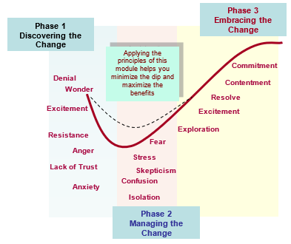

What words from the change curve describe how you are feeling going into the change?

What will be the hardest thing for you to do during the change?

What are several ways you can take charge of this change and be more proactive vs. resistant? If you were to stand up in front of a group and give a testimony of how you managed effectively through this change, what would be a great message? Think about the assessment results as well as your answer to these questions.

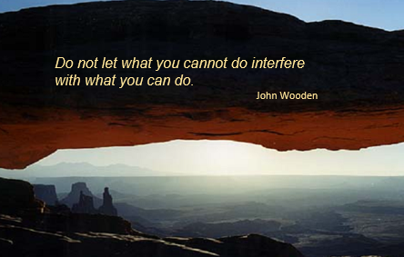

**5. Summary**

Every one of us will deal with thousands of changes in our lives. Many will have to deal with a severe change. To survive and thrive in the new reality, we must take charge of change rather than letting it take charge of us. This does not mean it will necessarily be easy but that we will have a process to deal head on with the change.

Take Charge of Change

This module provides some basic thought processes. The books and videos listed on the next page go into more depth. Employees who have a positive attitude during times of change will have a much better chance to survive and thrive in the future.

Leaders also have a responsibility to lead change efforts effectively and respectfully. The module Maximizing Change provides practical guidelines for leaders when managing change. You may want to read the self-study for several reasons. Everyone has some leadership aspects during change. You may be leading a family, a sports team, or a community organization. You may have your own side business. Also, you can coach your leader during times of change by letting them know when they are leading well through the change or when you see opportunities for improvement.

**Application**

**Books**

**Managing Transitions: Making the Most of Change**

William Bridges

**Who Moved My Cheese**

Spencer Johnson, MD

**Any books by John Kotter**

His books deal more with leading change than personally managing through change.

**Video**

Taking Charge of Change

CRM Learning

<http://www.crmlearning.com/taking-charge-of-change>

**Development Activities**

1. If you tend to be skeptical or resistant to change, pick one change you are facing and determine to be proactive and confident as you manage through the transition. Keep a short log showing some positive steps you took each day or week and the complaints you had and see if you can minimize the negative responses. This does not mean that you do not challenge leaders or others but that you do so with purpose and an attitude of support.

2. Coach someone else who is going through a significant change. Spend time listening to the person without responding except for asking inquiring questions. Then ask questions that might get them to think of 1 or 2 key next steps they can personally make. Help them see possibilities for how to move forward.

3. Take on an assignment or other challenge that you may not be comfortable with but will add value to you or others in the future. For example, take on an assignment at work you may not know much about, give a presentation to a group, lead a meeting, take a college course, travel to a new city, or request a meeting with a senior leader to learn about his or her job. By doing these types of activities, you are stretching yourself into new, sometimes uncharted areas that will help you be more comfortable in future challenges. Force yourself into uncomfortable situations.

4. The next time you go to a restaurant, try something you have never eaten before.

5. Explore a city or location you have not been to before.

6. Learn to not worry about looking stupid when you do not know something and are trying to figure it out. Do not be afraid to ask others for help. For example, I do not like to travel on mass transit unless I know the process. I have to force myself to ask people, read the signs, and just try it.

7. Read about people who have worked through and thrived during a severe change in life such as a loss of a relative, being permanently injured, losing life possessions, etc.

8. When change includes potential job reductions, you may be coached to find ways to stand out above your peers to improve your chance to secure a position. While you certainly want to do your best, managers will also observe how you support others on your team. During competitive employment situations, spend time helping all of your team succeed vs. competing with them. See the Conflict Resolution and Maximizing Employee Contribution modules for other ideas on how to personally grow and also support the success of those around you.

