Fostering Innovation

Facilitator
Guide

Overview | There are practical, non-costly leadership attributes that enhance the creativity and innovation of a team or organization. This module explores these attributes and helps leaders apply them to their organization.
Objectives | - Understand the business impact leaders have when they foster or inhibit creativity and innovation.  - Identify attributes that enhance creativity and innovation.  - Determine ways to expand the innovation of your organization.  - Apply this process to one challenge within your team.  - Create an action plan to increase how you foster innovation
Resources needed | There are several video options. See self-study to determine which ones to use.
Timing | 2-3 hours. Adjust the time depending on your organization and amount of focus needed on this topic. If needed, break this module into two segments. There are real work applications to do in the session or subsequent meetings.
Competency Connection | Listens actively  Empowers workforce  Engages employees for their knowledge  Executes goals  Leads situationally  Maximizes diversity
Related modules | Strong leaders foster innovation in the way they lead. Applying the NRL approach increases the team’s ability to grow the business. A few module connections are:  Reacting to Failure  - Leadership Styles  - Active Listening  - Receiving Constructive Feedback  - Delegation  - The Tier Model
Prework options | There are several case studies in this module. An option is to have participants read the cases and answer the questions ahead of the session. They can then discuss their answers during the session.
Optional video | Coach that Never Punts  https://www.youtube.com/watch?v=uUE7uytjmGw  The high school coach uses non-traditional coaching approaches resulting in many winning seasons.
New Reality Leadership

Facilitator Overview
Copyright 2010-2024 New Reality Leadership, LLC

Fostering Innovation

This module presents activities to help leaders unleash the creativity of their team. Many leaders inhibit employee creativity and potentially lower business competitiveness. In the next years, companies that mine creativity from their employees will survive. The world is changing so fast that we must maximize employee creativity, take prudent risks, and implement improvements quickly. Every employee has ideas and creativity. Effective leaders engage employees to mine their input. Also, employees who just want to show up and do their tasks may not stay competitive in the future.

The first part of the module presents case studies that highlight leader behaviors that foster or inhibit creativity. The participants discover these attributes and then complete activities to apply them.

There are suggested videos to help participants think expansively. A key to innovation is thinking outside of the box. Good brainstorming yields ideas that first seem impossible. Companies will need to stretch the way they think to stay competitive.

The Semmelweis case highlights that some leaders inhibit creativity because they feel threatened by their employee’s ideas. A Tier 3 leader is comfortable with maximizing employee contributions, acknowledging employees, and awarding them appropriately. In the New Reality, leaders will be recognized not for what they do but for how they bring out the best in their teams. The study guide has these four questions. Here are suggested answers to prepare you for the discussion.

Ignaz Semmelweis Discussion
Suggested views on the discussion questions.

Why do you think the leaders and prominent physicians were not receptive to Semmelweis’s discovery?

They may have felt threatened by a young, new physician finding a solution that they said could never be solved. They were supposed to be the most prestigious doctors in the world. They did not want a new person to be more recognized then they were.

Who did accept his discovery and support him?

His peers did accept the idea. They had no previous reputation.

How long was it from when Semmelweis discovered the cause, demonstrated success, and its universal acceptance?

It took almost 20 years. Think about how many women and children died because leaders were more concerned about their image and reputation than finding real solutions.

What was the negative impact of not exploring the findings more?

There were thousands of deaths. Think about how many companies have gone out of business or have become less competitive because leaders would not acknowledge the creativity and innovation of their employees.

How does this story relate to your organization, if at all? What problems continue to exist in your organization that leaders inhibited in some way? What are some of your creative solutions to problems?

This question helps the group redirect their thinking from others to themselves. Hopefully, with all the discussions, there are insights they have now that they can apply to your area.

========
Continue to connect to the competency model. It is helpful for leaders to know what competencies they need to foster innovation and which competencies are strengthened by fostering innovation. See the competency focus section. The powerpoint slide provides the connection for you.

Drive the session to action at the end. The difference between a good training session and one that impacts the business is the ability of the leaders to drive the learning to a behavior change.

There are additional resources at the end to do later to help broaden the thinking and skills in this area.

Activity Type and Timing | Facilitation Steps
Pre-session activity  5 min while people arrive.  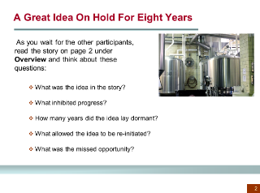 | Opening Exercise  While participants arrive, ask them to read the opening clean-out story explaining how leadership and peer reactions delayed an excellent idea for eight years. Show slide with focus questions and ask them to write down answers to these questions in preparation for the session.  At the beginning of the session, spend a few minutes asking for reflections from the participants.

Slide  1 min  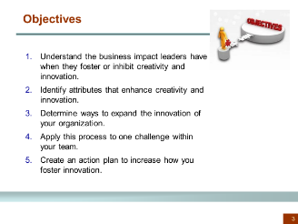 | Objectives  Share objectives with the group.
Slide or chart  1 min  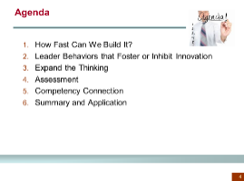 | Agenda  Share agenda for the day. See slide or make one on a chart.
Discussion and video  15 min  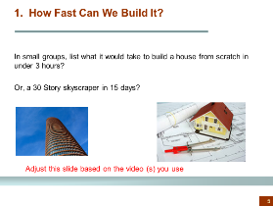 | 1. How Fast Can We Build It?  The 4 Hour House or Skyscraper Video  Intent: Show a video that demonstrates extreme out-of-the-box thinking. Innovation requires many ideas from different perspectives.  Facilitation Options  In groups of three, have participants brainstorm what it would take to build a house in three hours from scratch or a 30-story building in 15 days. Have each team share an idea. At first, some will say it is impossible but ask them to list as many ideas as possible.  Show a video: 2 or 4-hour house, or the 15 or 30 story buildings. Ask participants to watch and think about the expansive thinking required to accomplish the goal.  Debrief participant comments
Discussion  5 min  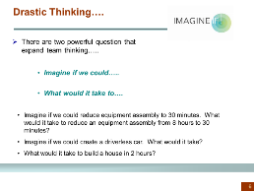 | Drastic Thinking  Intent: Introduce a powerful thought process that expands thinking approaches.  Show slide to introduce the concept. You will use the approach during an exercise. These two thoughts led to the innovation in the house and buildings.

Facilitator instructions | 2. Leader Behaviors that Foster or Inhibit Innovation  This section has three activities:  - Three Case Studies  - A Failing Restaurant  - Ignaz Semmelweis Case  You can do all or a portion of these activities and add other ideas as desired.
Small group exercise  3-5 min in groups  5 min debrief  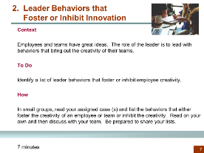 | 2. Leader Behaviors that Foster or Inhibit Innovation  Break the class into smaller groups and assign each group a case. This exercise gets the participants to identify/discover leadership attributes that foster or inhibit creativity and innovation.  Provide about 3-5 minutes for discussion and then have each group share their responses. Ask them to tell the story and then the identified characteristics.  Chart ‘Fostering Characteristics’ on one chart and ‘Inhibiting Characteristics’ on another chart.  Explain that these are areas that leaders impact creativity of their teams. The goal is to unleash creativity and innovation vs. inhibit it.
Group discussion  5 min  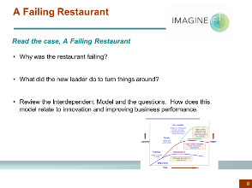 | A Failing Restaurant  Intent: Show example of improving a business using a few leadership behaviors which improved employee innovation.  Let participants read the case individually. Then, ask the participants to describe what the leader did to improve.
Group discussion  5 min  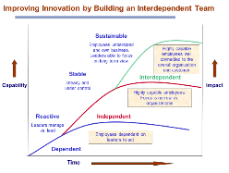 | Improving Innovation by Building an Interdependent Team  Show the model and have them briefly explain the intent. There are questions on the page to guide the discussion.  Note: Leaders must shift their behaviors and approach for employees to move to the independence and interdependence stage. Highly innovative teams operate in the third horizon.

Case study  10 min to discuss  5 min to debrief  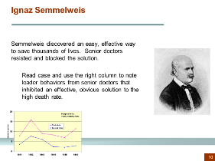 | Ignaz Semmelweis  Break the class into small groups of 3-4 people. Ask them to individually read the case and make notes in the right column and then to discuss and compare notes. They can use the questions to guide their discussion. Have them determine what the leaders did that inhibited the solution from being accepted.  See the beginning of this facilitator guide for details.  Chart their responses.
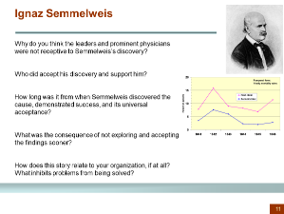 | Semmelweis Discussion Questions  Use these questions during your discussion. They are on the slide and in the workbook.
Group discussion  3 min  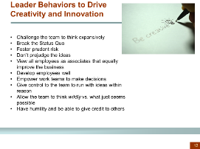 | Leader Behaviors that Drive Creativity and Innovation  Summary of Discussion  This discussion is a summary slide. Let the group read and then you can:  - Ask them to pick one that stands out to them  - Pick one that would have the most improvement impact  - Just review for now and use during the application exercise.

Small group work  10 min in groups  20-30 min to share  Overview slide  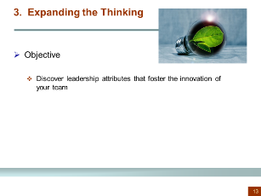  Exercise slide  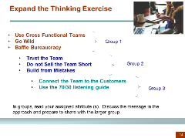 | 3. Expanding the Thinking  This section contains practical approaches leaders can take to foster creativity and innovation.  Break the class into small groups and assign them one to three approaches listed in this section. Their goal is to read, discuss, and then teach the other groups what this step is and why it is crucial to fostering innovation. They can share personal examples.  Allow about 10 minutes for group time and then 5 minutes for their teaching time back to the other groups.  Adjust slide instructions per group size.
Personal Application  5 min  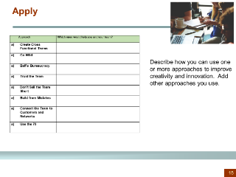 | Apply  Have participants work in the workbook and describe how they can use one or more approaches to improve creativity and innovation. Provide a few minutes to write and then ask for a couple of examples.
Assessment  15 min  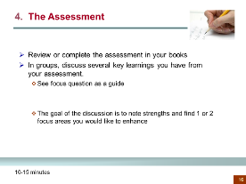 | 4. Assessment  Have participants fill in the assessment in their books. If they completed the assessment as prework, ask them to review quickly.  Then, in groups of 3, or as a large group, allow them to discuss key findings from the assessment. They can use the focus questions at the end of the assessment to guide their discussion. This discussion helps them to see strengths and opportunities they and others have around this topic.

Group discussion  5 min  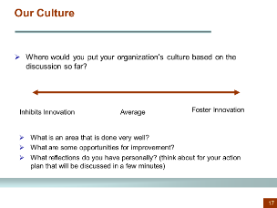 | Our Culture (Optional Discussion)  Intent: Allow the group to think beyond their team or area and focus on the company approach. Some company cultures foster innovation while others do not. Even if a company does not encourage innovation, a team can apply the methods to improve engagement and innovation.  Share slide and have them put a mark on the line representing the company approach.  Or, make a chart and have them put a dot on the chart. Discuss the findings and views. There are guide questions on the slide.
Group discussion  3 min  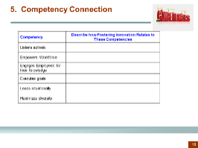 | 5. Competency Connection  Ask them to review the connected competencies to see how this module supports the development of those competencies. This discussion helps the leader connect several related competencies. When leaders learn new skills and concepts, it helps them grow in multiple competencies.
Group exercise  Up to 1 hour depending on the scope of ideas.  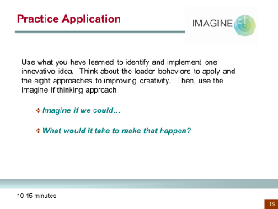 | Practice Application  Intent: Apply the learnings to a real opportunity to improve creativity and innovation. This exercise could be part of the workshop or schedule a separate time within the next couple weeks to have them apply the concepts to a specific need.  Have them work in groups based on actual work focus. Ask them to pick an improvement idea and use the Imagine if and what would it take approach.  The book provides additional guiding questions.

Group discussion  5 min  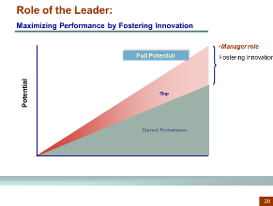  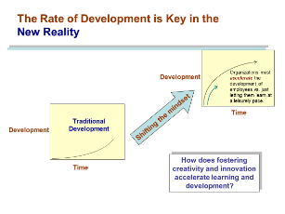 | Review the 2 Theme Charts  Review the two theme charts to make the connection between how Fostering Innovation helps maximize contribution and performance at an accelerated rate.  Show the Maximize Performance Chart and ask participants why they think fostering innovation can help maximize performance.  Then, show the Accelerating Performance chart and ask the same question. See chart for facilitator idea.
Group discussion  10 min  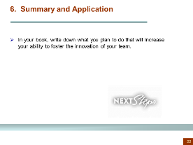 |  | 6. Summary and Application  Provide a few minutes for them to fill in application ideas in the workbook. Use the next slide of objectives for them to share an idea.
Slide  3 min  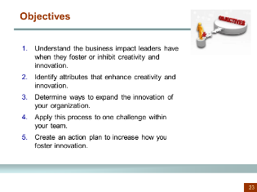 |  | Objectives  Review the objectives. Ask for a learning or application example. Ask them to connect the response to one or more objectives.
Review or discussion  7 min  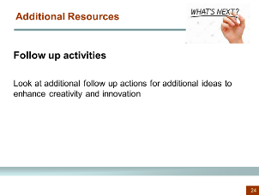 |  | Additional Resources  There are additional books and videos they can do, or you can create a follow-up activity using the resources.

