**Building Leadership Capacity**



**Fostering Innovation**

##### Fostering Innovation

*New Reality Leadership*

Copyright 2010-2024 New Reality Leadership, LLC

**Overview**

A great idea on hold for eight years

A technician in a pharmaceutical organization had an idea to reduce the time between product runs by implementing a self-washing process in the equipment. The factory ran about 50% of the time. The other 50% involved washing the equipment. Any decrease in downtime would increase production and profits. He tried several experiments, but peers and leaders chastised him for the idea. Even a global changeover team said that the idea would not work on this type of equipment.

Eight years later, another technician remembered the idea. His manager, newer to the area, suggested he try some experiments with the process. The manager gave this technician funds for pumps, piping, and engineering resources. They tried several experiments and created a way to make the idea work. Now, technicians were not exposed to toxic materials. They increased uptime to 70% which increased profits.

Eight years passed with a creative and innovative idea sitting on the shelf. There were many wasted hours which slowed production. The second manager applied leadership attributes that foster ideas and creativity. Even when failures occurred in the experiments, the leader got employees together to brainstorm suggestions and solutions. He saw failure as a means to the end…..and it worked.

This module focuses on approaches leaders can apply to bring out the creative ideas of their group and increase innovation. Your team will have engaged employees who impact business results.

|  |  |  |
| --- | --- | --- |
|  |  | **Objectives**   1. Understand the business impact leaders have when they foster or inhibit creativity and innovation. 2. Identify attributes that enhance creativity and innovation. 3. Determine ways to expand the innovation of your organization. 4. Apply this process to one challenge within your team. 5. Create an action plan to increase how you foster innovation |
|  |  | **Contents**   * 1. How Fast Can We Build It?   2. Leader Behaviors that Foster or Inhibit Innovation   3. Expand the Thinking   4. Assessment   5. Competency Connection   6. Summary and Application   1. |

**Getting Started**

Companies have gone out of business by leader attributes which squash employee creativity and innovation. Companies have accomplished extraordinary things by following the principles of this module. Learn how organizations applied these concepts to build houses in two hours or skyscrapers in just days vs. years. Learn how leaders caused thousands of deaths because they did not implement one of the principles.

One organization applied this concept and created 70 patents in one year that went to market building a one-billion-dollar business. The potential is unlimited. Companies that employ these concepts will improve revenue and stay competitive. Companies that do not will struggle. Read and explore the ideas and see how many you can use with your team.

**1. How Fast Can We Build It?**

The world is changing quickly. Innovative companies will be competitive companies. Look at one or several of the videos and list the impact or result of the innovation.

[House Built in Texas](http://www.youtube.com/watch?v=I2HqW-AAb20)

[4 Hour House](https://www.bing.com/videos/search?q=youtube+2+hour+house&view=detail&mid=946A1EE1281DD30293D4946A1EE1281DD30293D4&FORM=VIRE)

[Building a 15-Story building in 6 days](https://www.bing.com/videos/search?q=youtube+building+in+15+days&&view=detail&mid=393443B13EF30FF11E30393443B13EF30FF11E30&&FORM=VRDGAR)

Describe the impact of these innovative approaches.

Organizations create a process and become comfortable with the time and quality. Innovative companies continually challenge the status quo and explore improvements.

There is an approach that drives innovation. This approach expands team thinking. In one example, trainers reduced the training time from 18 months to 5 months. In another case, technicians cut the time to take a piece of equipment apart from 4 hours to 2 minutes.



The approach is:

*Imagine if we could_________________________________________________*

*What would it take to make that a reality?*

*Imagine if* we could have a man walk on the moon? What would it take to do that?

*Imagine if* we could build a house in two hours.

*Imagine if* we could build a 15-story building in 6 days.

*Imagine if we* could reduce cleaning time from 4 hours to 5 minutes

We will identify leader behaviors and team approaches that foster or inhibit creativity and innovation.

**2. Leader Behaviors that Foster or Inhibit Innovation**

Leaders foster or inhibit innovation by their behaviors. A role of the leader is to maximize employee contribution which drives innovation and business improvement. Read the following cases and list the positive or negative behaviors associated with the situation.

Activity 1: Three Cases

Activity 2: The Restaurant

Activity 3: Ignaz Semmelweis

**Cases**

Read the following cases. In the right-hand column, make notes of leader attributes that either foster or inhibit creativity of their employees or organization. These are the attributes we will focus on during this session. Also, describe the impact on employees or the organization.

|  |  |
| --- | --- |
| **Case 1**  It took operators 8 hours to take apart, clean and reassemble a piece of equipment. The operators brainstormed ideas to reduce this time. They listed over 50 ideas and proposed 10 to leadership. The cost of these changes was $15,000.00. Leaders accepted all ten ideas immediately, trusting the approach. With the upgrades, it took two minutes to disassemble the vessel and ten to reassemble. They did this task every three weeks saving time and increasing production time. They recovered the costs within three months. |  |
| **Case 2**  A manufacturing company could not make enough of a product to meet customer requests. The technical staff met for several years trying to come up with ideas to increase the product amount with no success. A new leader came in and within eight months increased output by 25% or one million dollars per month.  The previous leadership team did not ask operators and mechanics for ideas. The new leader shared the business goals and opportunities with the operators and mechanics and got them to brainstorm ideas to increase production rates. These front-line employees had hundreds of ideas they immediately applied. |  |

|  |  |
| --- | --- |
| **Case 3**  Employees in one retail chain received 8 hours of training when they started. They learned everything else on their own as they had time. In another retail chain, the employees received 225 hours of training every year. They learned how to focus on customers, how to sell, product features, marketing skills and much more.  The first chain had poor sales and 75% employee turnover each year. The second chain had exceptional sales and 7% turnover per year. Leaders viewed employees in the first chain as a pair of hands to stock shelves and run cash registers. Leaders in the second chain regarded employees as innovative associates that continually helped improve operations.  The first chain went out of business and the second chain outperformed all industry competitors. |  |

The operating group in Case 1 asked,

*“Imagine if we could reduce cleaning time from 4 hours to 30 minutes. “What would it take to achieve this goal?*

That approach created a storm of ideas that led to the 2-minute time. These operators applied this thinking to the entire process and had incredible results.

**A Failing Restaurant**

A restaurant was failing due to poorly trained and engaged employees and chaotic systems. A new leader used the model in our module called Role of the Leader to change the approach which doubled revenues.

He developed a strategy to shift employees from the dependent to the independent stage in this model. He did that by:

* Training them in all areas of the restaurant
* Engaging them for improvement ideas
* Empowering them to make many decisions without management approval

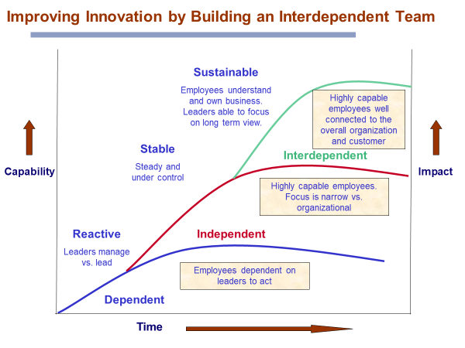

Shifting employees to the Independent stage allowed them to understand the restaurant operation, sales, costs, and challenges. Leaders engaged them for ideas leading to innovative improvements which increased profits.

The next step was to shift employees to the Interdependent Stage, but the owners resisted this step and the manager eventually left.

Why do you think shifting employees from a dependent to an independent stage positively impacts business results?

What are a few leadership behaviors needed to create this shift to independence?

**Fostering or Inhibiting Innovation**

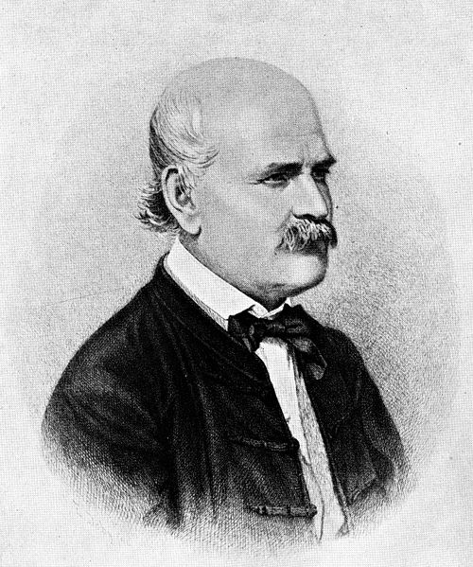

A physician found a solution that could have saved thousands of lives. Senior physicians resisted the solution resulting in continued deaths. Read the case to determine the leader behaviors that delayed an obvious incredible answer to a deadly disease.

**Ignaz Philipp Semmelweis**

Think about a leader’s role in fostering or inhibiting an effective, impactful idea. Make notes in this column that stand out to you.

Primary Contributor: [Imre Zoltán](http://www.britannica.com/bps/user-profile/3316)

Article from the Encyclopedia Britannica. January 2, 2011

**Ignaz Philipp Semmelweis** (August 13, 1865, Vienna, Austria),  German-Hungarian physician who discovered the cause of puerperal (“childbed”) fever.

Educated at the universities of Pest and Vienna, Semmelweis received his doctor’s degree from Vienna in 1844 and was appointed assistant at the [obstetric](http://www.britannica.com/EBchecked/topic/424088/obstetrics" \o "obstetric) clinic in Vienna. He became involved in the problem of **puerperal infection**, the scourge of maternity hospitals throughout Europe. Although most women delivered at home, those who had to seek hospitalization because of complications faced **mortality rates ranging as high as 25–30 percent**. Some thought that the infection was due to overcrowding, poor ventilation, or other unknown issues. Semmelweis investigated its cause *over the strong objections of his chief, who, like other high-level physicians, had determined there was no solution to the problem.*

The [death rate](http://www.britannica.com/EBchecked/topic/393100/mortality" \o "death rate) from [childbed fever](http://www.britannica.com/EBchecked/topic/482821/puerperal-fever) in the first ward **was two or three times** as high as among those in the second ward. The two wards were identical with the exception that they taught students in the first and midwives in the second. Semmelweis hypothesized that the students carried something to the patients they examined during [labor](http://www.britannica.com/EBchecked/topic/445271/parturition" \o "labour). He concluded that doctors who came directly from an autopsy to the maternity ward carried the infection from mothers who had died of the disease to healthy mothers. He ordered the students to wash their hands in a solution of chlorinated lime before each examination.

The mortality rates in the first division dropped from about 18 to 1 percent. The *younger medical men* in Vienna recognized the significance of Semmelweis’ discovery and gave him *all possible assistance.* ***His superior*** was critical because it would be humiliating for a new, young doctor to discover a simple solution to such a devastating problem. These physicians were the elite in Europe and their reputation was in jeopardy.

He worked for the next six years at the St. Rochus Hospital in Pest. An epidemic of puerperal fever broke out in the obstetrics department, and the put Semmelweis in charge of the department. His measures promptly reduced the mortality rate to 0.85 percent. *In Prague and Vienna the rate was 10 to 15 percent.*

They accepted his ideas in Hungary, and the government ordered the application of his methods. *Vienna remained hostile toward him, and the editor of the Wiener Medizinische Wochenschrift wrote that it was time to stop the nonsense about the chlorine hand wash.*

In 1861 Semmelweis published his principal work… “Etiology, Understanding and Preventing of Childbed Fever” He sent it to all the prominent obstetricians and medical societies abroad, but the *general reaction was adverse*. The weight of authority stood against his teachings. He addressed several open letters to professors of medicine in other countries, but to little effect. At a conference of German physicians and natural scientists, most of the speakers—including the pathologist [Rudolf Virchow](http://www.britannica.com/EBchecked/topic/629797/Rudolf-Virchow)—rejected his doctrine.

It took 20 years for medical science to accept Semmelweis’ solution and Joseph Lister hailed his work. “I think with the greatest admiration of him and his achievement, and it fills me with joy that at last he is given the respect due to him.”

http://www.britannica.com/EBchecked/topic/534198/Ignaz-Philipp-Semmelweis

**Focus on your Organization**

Why do you think the leaders and prominent physicians were not receptive to Semmelweis’s discovery?

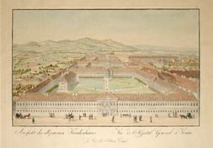

Who did accept his discovery and support him?

How long was it from when Semmelweis discovered the cause, demonstrated success, and its universal acceptance?

What was the consequence of not exploring and accepting the findings sooner?

How does this story relate to your organization, if at all? What inhibits problems from being solved?

These leader behaviors foster innovation.

* Challenge the team to think expansively
* Break the Status Quo
* Foster prudent risk
* Don’t prejudge the ideas
* View all employees as associates that equally improve the business
* Develop employees well
* Empower work teams to make decisions
* Give control to the team to run with ideas within reason
* Allow the team to think *wildly* vs. what just seems possible
* Have humility and be able to give credit to others

List several applications for your team. Remember, your role is to foster the creativity and innovation of your team. Think about any behaviors you want to continue and any to avoid.



**3. Expand the Thinking**

There are tools to expand creative thinking. This module does not go into these tools but provides attributes for applying as a leader. Add your ideas to this list.

1. Create Cross-Functional Teams
2. Go Wild



1. Baffle Bureaucracy
2. Trust the Team
3. Don’t Sell the Team Short
4. Build from Mistakes
5. Connect the Team to Customers and Networks
6. Use the 70/30 Listening Balance

**a. Create Cross-Functional Teams**

Ideas are a foundation for creativity. Like shooting goals in hockey or soccer, it takes many shots to score a few goals. The same applies to innovation. Many ideas may create a few break-through solutions. The role of the leader is to foster an atmosphere that welcomes the ideas. Cross-functional teams are typically short-term project teams. A team may work together for several hours or several months. Read the following case to determine the method used to increase the number and breadth of ideas in Southwest.

**Southwest Approach to Collaboration**

Notice the makeup of this team.

For many companies, cross-functional collaborations last weeks or months, not years. Southwest recently gathered people from its in-flight, ground, maintenance, and dispatch operations. For six months they met for 10 hours a week, brainstorming ideas to address a broad issue: What are the highest-impact changes we can make to our aircraft operations?  
  
The group presented 109 ideas to senior management, three of which involve sweeping operational changes. One solution about to be introduced will reduce the number of aircraft "swaps" -- disruptive events that occur when one aircraft must be substituted for another during mechanical problems. Chief Information Officer Tom Nealon says the *diversity* of the people on the team was crucial, mentioning one director from the airline's schedule planning division in particular. "He had almost a naive perspective," says Nealon. "His questions were so fundamental they challenged the premises the maintenance and dispatch guys had worked on for the last 30 years." (Bloomsburg Businessweek: The World’s Most Innovative Companies, April 24, 2006)

Describe your culture of using collaborative teams to generate new ideas?

Do you enlist the folks who are doing the job for their ideas?

Do you bring in outside folks such as customers, marketing, sales, and just creative people to gain multiple perspectives?

List application ideas based on a collaborative approach to help your area.

**b. Go Wild**



A leader’s role is to extract every possible idea from the team. Get the team to think of almost impossible ideas. Start broad and narrow it down. By thinking wildly at first, your team may uncover an unconventional approach that will make the difference. Think about how bizarre it is to build a house in less than three hours or a 30-story building in 15 days. In good brainstorming, some ideas should almost seem impossible. If not, stretch your thinking further.

Can you think of a crazy idea that has helped your area or company?

What is one possible idea that would change your company or units approach?

**c. Baffle Bureaucracy**

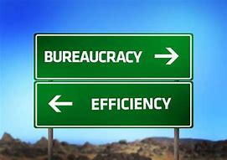

A team worked in one organization within a company. When they introduced ideas, it took months or years to get an idea through…or dismissed. Several team members moved into a new organization within the company. They would present an approach, be approved and implement the idea within days or weeks. The leader of this group trusted the team. She gave them the freedom to move….and they made things happen. Same people, a different leader who knew how to foster innovation…. different results!

What is your culture in this area? List one positive trait and one challenge you have noticed in this area.

**d. Trust the Team**

Sometimes you need to trust the team and let them try. Build and develop your team to work interdependently. Interdependent teams have knowledge and business understanding. They bring innovative ideas to the business if you engage them. Autonomy and trust correspond with skill and motivation.

A manager asked to be involved in every correspondence with clients from his employee. The leader constantly challenged the ideas. The employee became tentative and just let the manager suggest a course of action. Since the manager was not intimately involved with the clients, the ideas or approaches often missed the mark. The client satisfaction went down drastically.

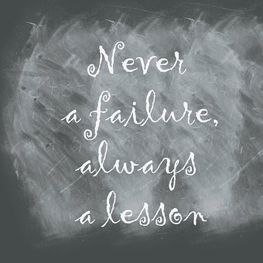

**e. Don’t Sell the Team Short**

Be careful to limit what you think an employee or team can do.

A country club manager was upset that members continued to take complimentary items from the locker room such as shaving cream, aftershave, and lotions. He put up signs and tried to stop the theft. A janitor overheard his frustration one day and said he had the answer. Take the lids off open containers so they can not put them in their bags without spilling them. Problem solved.

A plant manager viewed an operator as a ‘pair of hands.’ He thought he was a high school dropout and would not have any meaningful input for improving the business. One evening as he walked to his car, he met the operator and asked what his plans were for the night. The operator was president of the school board and they had their monthly meeting. The school district was one of the best-run districts in the state. This operator also was a computer programmer. Get to know employees and mine their talents.

**f. Build from Mistakes**

Use mistakes, when possible, as a springboard for discovery and learning. Get them to identify the issue and how to approach the situation in the future. When employees know you will not reprimand them for getting off course, they will expand innovative approaches.

How would you rate your company’s culture in reacting to mistakes?

Inquires and coaches when addressing mistakes

Reacts quickly and negatively to mistakes

**g. Connect the Team to Customers and Networks**

New ideas increase when employees interact with the final customer and the next internal group they are supporting. Through this interaction, they can identify customer challenges or satisfaction.

A team of operators traveled to another company site that converted their intermediate product into the final product for customer sales. During their week stay, they saw useful operating techniques and equipment arrangements that they had never considered for their area. Upon returning, they innovatively adapted many improvements.

Failure is not the opposite of Success….it is part of it.

Company leaders in an agricultural business sent employees to visit farmers across the country. They asked the farmers for their views of the products and what suggestions they had for improvements. The employees generated many ideas and sales grew by 30%.

**h. Use the 70/30 Listening Balance.**

Inquire for understanding before sharing ideas. Let the group explore first before advocating your thoughts especially if they have the motivation and skills.

Two employees asked for 30 minutes to share a creative idea with their director. The employees did not get through the first minute before the director interrupted and began to critique the first point. They never shared or implemented the idea.

Ask questions and listen for understanding before advocating a view.

**Approach Summary**

We discuss a few approaches that improve creative thinking. Add your methods. Using the space below, write insights you gained from this section and discussion to apply with your area.

|  |  |
| --- | --- |
| **Approach** | **Which ones would help you and your team?** |
| 1. Create Cross-Functional Teams |  |
| 1. Go Wild |  |
| 1. Baffle Bureaucracy |  |
| 1. Trust the Team |  |
| 1. Don’t Sell the Team Short |  |
| 1. Build from Mistakes |  |
| 1. Connect the Team to Customers and Networks |  |
| 1. Use the 70/30 Listening Balance |  |

**4. Assessment**

Leaders unleash individual and team creativity. Each assessment item relates to enhancing the creativity from a leadership viewpoint. Complete the assessment to get ideas of your strengths and opportunities. The appendix has an explanation of how these items impact creativity and innovation.

|  |  |  |  |
| --- | --- | --- | --- |
| **Creativity Area** | **Needs some work** | **Do OK** | **Do well** |
| 1. I encourage my team to take prudent risks. |  |  |  |
| 2. I view mistakes as learning opportunities. |  |  |  |
| 3. I expect some failure to occur because my team has a trial and error mentality. |  |  |  |
| 4. I like to explore ideas rather than prematurely judge them. |  |  |  |
| 5. I use a diverse team to generate ideas. |  |  |  |
| 6. I gain a variety of perspectives vs. just one or two team members when solving problems. |  |  |  |
| 7. I provide a creative environment for my team if we need to generate solutions for problems or challenges. |  |  |  |
| 8. I separate idea generation from idea evaluation. |  |  |  |
| 9. I am proactive in addressing current or potential challenges. |  |  |  |
| 10. I update my team about the company direction so they can connect their work with the plan. |  |  |  |
| 11. When people are critical of a process change, I ask them for their ideas and solutions. |  |  |  |
| 12. I acknowledge creative solutions and give credit to the team. |  |  |  |
| Totals for each |  |  |  |

* What strengths do you bring to your team that allows you to unleash their creativity?
* Based on this survey and your knowledge, what can you focus on to enhance the creativity of your team?
* Describe how improved innovation will improve business performance.

**Organizational Culture View**

How would you assess your company or organization’s approach to innovation? Place a mark on the line.

Average

Inhibits Innovation

Fosters Innovation

* What is an area that the organization does well?
* What are some opportunities for improvement?
* What reflections do you have personally?

It is easier to foster creativity and innovation when the senior leaders create the culture for this approach. Even if your organization overall does not encourage innovation, you can apply many techniques to improve innovation in your area.



**5. Competency Connection**

This module helps you improve the competency called Fosters Creativity and Innovation. Look at the other listed competencies to see how they are needed or enhanced by growing in this competency. There are relationships to other competencies, but these have strong connections.

|  |  |
| --- | --- |
| **Competency** | **Describe how Fostering Innovation builds these competencies** |
| Empowers the Team | Example: Empowering teams lets them take prudent risks, try new ideas, and implement solutions quickly. |
| Listens Actively |  |
| Engages employees for their knowledge |  |
| Executes goals |  |
| Leads situationally |  |
| Maximizes diversity |  |
| Fosters Collaboration |  |

**Practice Application**



Use what you have learned to identify and implement one innovative idea. Think about the leader behaviors to apply and the eight approaches to improving creativity. Then, use the Imagine if thinking approach.

Imagine if we could ____________________________________________________________________

What would it take to make that happen?

What behaviors will you apply to implement this idea?

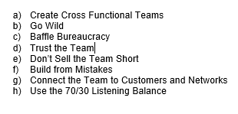

Which of the eight approaches will help you with the idea?

**Connect to our Models**

This module content helps leaders maximize the full potential and performance of employees at an accelerated rate. See if you can articulate these connections.

|  |  |
| --- | --- |
|  | How does this module content improve employee performance? |
|  | How can the leader behaviors accelerate or inhibit development? |

**6.** **Summary and Application**

Effective leaders foster the creativity and innovation of their employees, team, or organization. Leaders inhibit innovation by a few actions. They enhance innovation by applying the principles of this module. The goal is to mine all the ideas, creativity, and innovation from a team faster than before to improve people engagement and business performance.

**Application**

Pick a few areas you can control and think of ways to apply these concepts.

**Your Plan**

What leader approaches do you apply now?

What approaches would you like to improve?

What can you do now to unleash the creativity and innovation of your team?

What can you do to shift your culture to be more innovative?

**Appendix**

**Leader Behaviors** (From initial exercise)

|  |  |
| --- | --- |
| **Case 1**  It took operators 8 hours to take apart, clean and reassemble a piece of equipment. The operators brainstormed ideas to reduce this time. They listed over 50 ideas and proposed 10 to leadership. The cost of these changes was $15,000.00. Leaders accepted all ten ideas immediately, trusting the approach. With the upgrades, it took two minutes to take the vessel apart and 10 to reassemble. They did this task every three weeks saving time and increasing production time. They recovered the costs within three months. | Leaders developed and trained the technicians well and then gave them autonomy to improve their areas. They provided funds and took some risk. The operators made a clear presentation to leaders and leaders made a quick but prudent decision. This success led to many similar improvements.  **Leader Behaviors**   * Trained operators * Trusted the team * Took prudent risk * Empowered the team |
| **Case 2**  A manufacturing site could not make enough of a product to meet customer requests. The technical staff met for several years trying to come up with ideas to increase the product amount with no success. A new leader came in and within eight months increased output by 25% or one million dollars per month.  The previous leadership team did not ask operators and mechanics for ideas. The new leader shared the business goals and opportunities with the operators and mechanics and got them to brainstorm ideas to increase production rates. These front-line employees had hundreds of ideas they immediately applied. | Leaders tried to solve the problem on their own without involving all people. People close to the product or customer have great ideas. The new leader understood the value of asking the frontline team and found many innovative ideas.  **Leader Behaviors**   * Share business challenges with all employee. * Engage all employees for ideas. * Give employees credit and recognition for finding improvements |

|  |  |
| --- | --- |
| **Case 3**  Employees in one retail chain received 8 hours of training when they started. They learned everything else on their own as they had time. In another retail chain, the employees received 225 hours of training every year. They learned how to focus on customers, how to sell, store product features, marketing skills and much more.  The first chain had poor sales and 75% employee turnover each year. The second chain had exceptional sales and 7% turnover per year. Leaders viewed employees in the first chain as a pair of hands to stock shelves and run cash registers. Leaders in the second chain regarded employees as innovative associates that continually helped improve operations.  The first chain went out of business and the second chain outperformed all industry competitors. | Poorly trained employees do not know how to make many improvements. Training employees, valuing them as equals, and engaging them for ideas produces innovative ideas that improve business performance.  **Leader Behaviors**   * Train employees well. * Value employees as equals. * Share the business challenges and goals with all employees. * Engage employees for ideas and let them implement ideas when possible. |

**Supplemental Resources**

|  |  |
| --- | --- |
|  | **Mars Path Finder Project** |
|  | Learn how the project leader fostered the creativity of his team to accomplish the successful Pathfinder mission to Mars and how they overcame constant barriers. They succeeded even with low resources (finances, people, time). As a team, read one section per group session and discuss the leadership approach used. This module contains the elements noted in the book.  by Price Pritchett, Brian Muirhead |
|  | **2 Hour House**  Shows how a creative and innovative team built a house in less than 3 hours.  by Brian Conaway (Author), Jose Feliciano (Author) |

**Videos**

|  |  |
| --- | --- |
|  | **Leadership and Self-Deception**  Watch a video version of the Ignaz Semmelweis case study to see additional insights.  [Order and Video Trailer](http://www.crmlearning.com/leadership-and-self-deception) |
|  | **IDEO**  View a company that applies the behaviors and eight innovation approaches to create new products.  [Link](https://www.bing.com/videos/search?q=ideo+company&qft=+filterui%3amsite-youtube.com&view=detail&mid=B8FAB6B4C4D6B1F238EAB8FAB6B4C4D6B1F238EA&&FORM=VRDGAR) |
|  | **The Coach that Never Punts**  [**https://www.youtube.com/watch?v=uUE7uytjmGw**](https://www.youtube.com/watch?v=uUE7uytjmGw)  This high school team uses non-conventional approaches to winning football games. See how they challenge traditional coaching which leads to many more team wins. Leaders often follow what they have seen which is not always the best way. Learn to ask questions and challenge the status quo. |