New Reality Content
New Reality Leadership content has several focus areas. The foundational material focuses on improving organizational strategy and presents four leadership principles that effective organizations exhibit.
The next area presents the coaching focus. The Coaching Approach aligns leaders on coaching foundations and introduces the Tier Model. The Tier Model is a methodical, proven approach to coach and develop employees to maximize their performance.
The next area focuses on Improving Feedback and Communication. Effective leaders and coaches apply the approaches explained in these modules.
Leading and Managing change is a competency needed by all leaders. These modules provide practical tools to help leaders navigate the teams through change.
There are additional resources you can weave into your development process and our website provides on-going links to articles, books, and seminars to help leaders grow and develop. We offer an approach that allows leaders learn while they run their business with minimal time away from work.
There are several starting points depending on specific needs. A general suggested flow is from left to right and top to bottom in each section.
This process is not a race to complete the curriculum. It may take two to three years to conduct and integrate the thinking and skills into your organization. It is better to go slower and ensure the process is cemented and applied than to push through to complete a timetable.
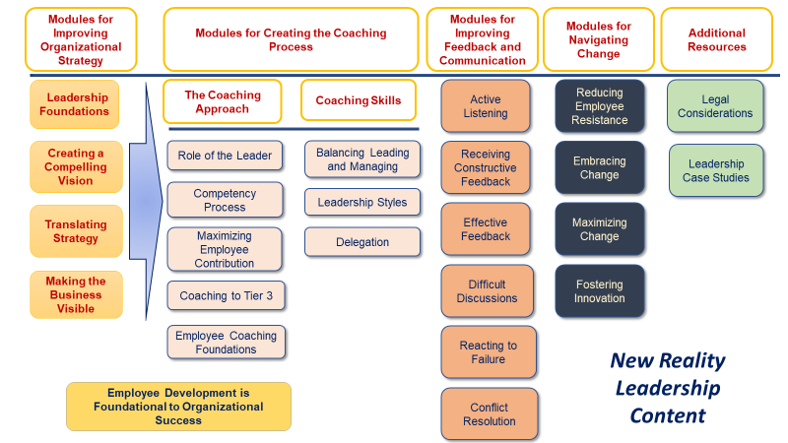

Organizational Strategy Modules
These modules provide the foundational mindset for New Reality. They provide the leadership principles and then practical tools and ideas to implement them.
 | Module Title | Description
1 | Leadership Foundations | This overview module explains the overall purpose of New Reality and how to maximize the process to build leader competency so they can maximize employee contribution to grow business results. It describes the foundation modules listed next and the overall New Reality Content.
2 | Creating a Compelling Vision | This study provides provocative ideas to help create a compelling vision. Many employees do not understand their company vision or how their work supports the vision. Applying the concepts of this module will significantly enhance your vision process.
3 | Translating Strategy | Employees are not always clear on the most important goals or challenges of their leaders. Translating Strategy provides practical ways leaders can ensure all employees are clear on the strategy and how to help leaders execute effectively.
4 | Making the Business Visible | Many employees see only their work but not the overall goals or status of the business. The more employees know their role and understand the business goals, the more potential they have to maximize their ability to grow the business. This module provides ways to help employees see the score of critical business focus areas so they can help improve these areas.

Modules Creating the Coaching Approach
These modules provide the core thought processes for New Reality and a coaching approach to align leaders on how they develop and maximize their teams. Many modules provide tools and exercises for leaders to use with their teams.
 | Module Title | Description
5 | Role of the Leader | This module provides the principles for leadership and supports the four leadership foundations. If managers/leaders considered these areas when making decisions or interacting with employees, they would improve their overall leadership approach.
6 | The Competency Process | New Reality has a Leader Competency Model. If your organization has a competency model, you may align yours with NRLs. Each facilitator guide provides a list of related competencies for that module. NRL has a unique approach to competencies which we describe in this module.
7 | Maximizing Employee Contribution | This module introduces the 3-phase Tier Model. It describes characteristics of employees who work in either a Dependent, Independent or Interdependent approach. Employees and leaders learn the process and conduct an assessment to identify the current state. They then complete the next two modules, Coaching to Tier 3 and Employee Coaching Foundations to create a practical development plan to grow toward Tier 3. There are two modules: one for leaders and one for employees.
8 | Coaching to Tier 3 | Coaching to Tier 3 helps leaders create a practical and respectful plan to help employees grow in selected Tier 3 characteristics that will maximize their growth and make a significant business impact.
9 | Employee Coaching Foundations | Employers do not always fully know their employees and potential. This module provides an interactive assessment with employees to get to know their skills and desires. Leaders use this information to enhance the development plan.

Coaching Skills

 | Module Title | Description
10 | Balancing Leading and Managing | Leaders need to manage day-to-day activities and also provide leadership and guidance to move an organization forward. Most leaders get mired in the managing side leaving little time to lead. This module offers advice on how to make the managing focus efficient to free up time for the leadership side. The rest of the NRL content then focuses mostly on improving the leadership skills.
11 | Leadership Styles | Leaders often lead with one primary approach. Effective leaders know how to shift leadership styles for employees and teams based on skill level and motivation. There are three styles discussed in this module. Leaders learn how to use each method and when to use depending on their team makeup.
12 | Delegation | Delegation provides tactical tools and ideas to help leaders delegate simple to complex work.

Improving Feedback and Communication
13 | Active Listening | Most people speak more than they listen. One characteristic of a great leader is to listen first for understanding. Leaders learn the 70/30 listening balance: listen 70% of the time especially when coaching employees.
14 | Receiving Constructive Feedback | One significant way to become an effective leader is to build trust in employees and peers to provide you with constructive feedback. Leaders who resist input will not be as successful as ones that are fully open to feedback. Professional athletes and musicians receive constructive feedback daily even when they are the best in the world. Leaders need to take the same approach if they want to be world class.
15 | Effective Feedback | Many of us give little feedback let alone useful and positive feedback. This module provides tools for especially the positive feedback.
16 | Difficult Discussions | This module provides a framework for leaders to hold a difficult discussion. This framework is especially helpful for leaders who tend to avoid these discussions.
17 | Reacting to Failure | Responding harshly to mistakes disengages employees. This module provides guidance on how to initially respond to an employee or team when they make a mistake. If leaders cannot get this one interpersonal skill right, it will be almost impossible to be an effective leader.
18 | Conflict Resolution | Many books provide guidance on resolving conflict. This module offers activities to reduce conflicts within the group. Every module in New Reality is a piece of a puzzle for leaders to prevent or manage conflicts. This module focuses on a few targeted activities.

Navigating Change
19 | Reducing Employee Resistance | Employee resistance is a visible behavior of hidden attitudes. This module provides thought-provoking ideas to uncover resistance from your team. (works with teens as well)
20 | Embracing Change | Change is happening faster than ever. An essential competency of employees will be their ability to embrace change vs. fear it. Learn ways to take charge of change vs. letting it paralyze you. This module is helpful for employees and leaders.
21 | Maximizing Change | A competency for leaders is first to embrace change themselves and then help their team make the most of the change. Leaders who can master this competency will unleash employee performance and overall team execution even with constant change.
22 | Fostering Innovation | Many ideas lay dormant in employees due to them not feeling safe in trying things or taking prudent risks. Leaders can use the tips and tools in this module to ensure they are providing an avenue for every employee to bring out the best ideas to solve problems and keep up with the pace of change.

Additional Resources
23 | Legal Considerations | Understand the behaviors and actions that create legal challenges and how to strengthen your organization to avoid these areas.
24 | Application Case Studies | This module provides around 100 case studies leaders can discuss and determine how they could apply good leadership practices. These cases are situations leaders often face where they need to make decisions or seek help from others such as HR or the legal department. We recommend that you weave these discussions throughout the leadership journey vs. doing as one module.

